BESEMA’S STRATEGIC ROLE IN MAINTAINING CLEAN AND HEALTHY IDP ENVIRONMENTS IN BENUE STATE

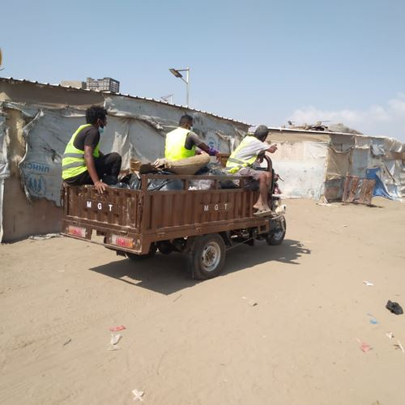
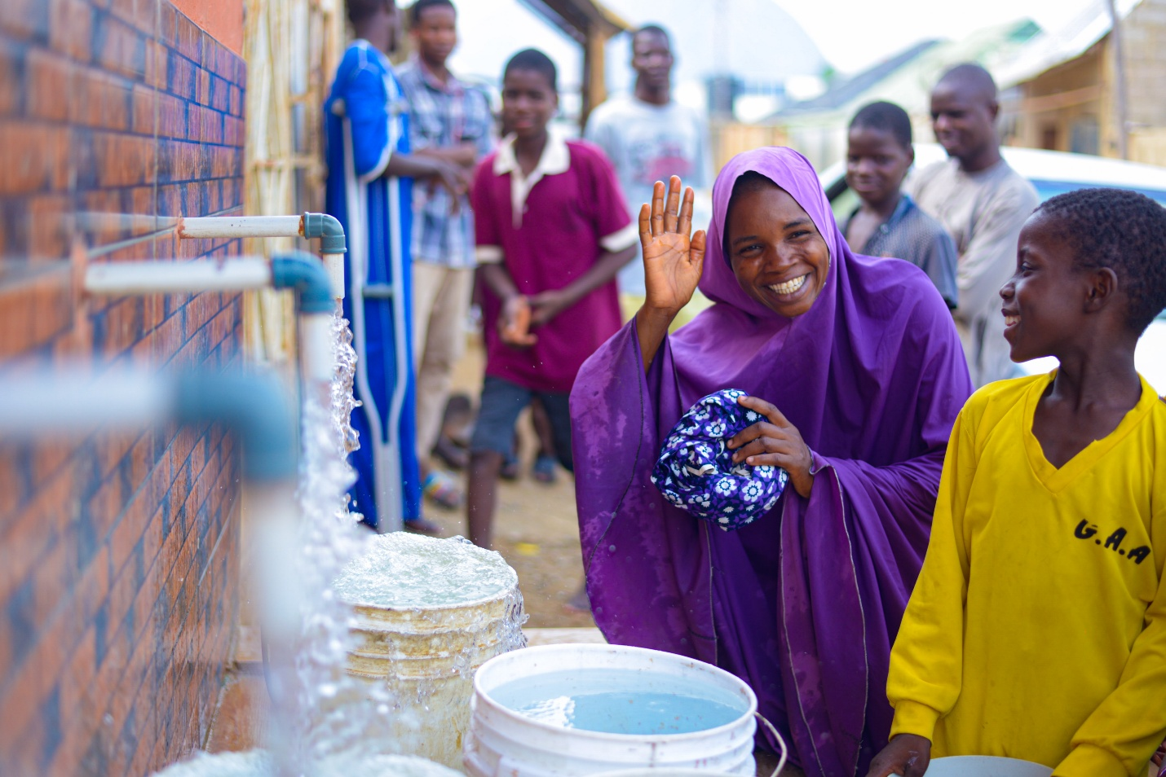
4
The Benue State Environmental Sanitation and Management Agency (BESEMA) plays a vital and humanitarian role in safeguarding environmental health within Internally Displaced Persons (IDP) camps across Benue State. Given the unique vulnerability of displaced populations, maintaining a clean and sanitary environment is not merely a public service responsibility; it is a moral and public health imperative.
Below is a professionally articulated overview of how BESEMA sustains environmental cleanliness and promotes public health in IDP settlements:

1. Strategic Waste Management and Disposal
BESEMA ensures structured and routine waste collection within IDP camps through:
- Deployment of sanitation personnel and waste collection teams
- Provision of waste bins and designated dumping points
- Safe evacuation and environmentally compliant disposal of refuse
This structured approach prevents indiscriminate waste dumping, reduces environmental hazards, and minimizes the outbreak of communicable diseases.

2. Environmental Health Surveillance and Monitoring
The Agency conducts regular environmental inspections to:
- Identify sanitation gaps and risk areas
- Monitor water sources and drainage systems
- Enforce hygiene standards in collaboration with camp authorities
Through proactive surveillance, BESEMA mitigates health risks such as cholera, typhoid, malaria, and other sanitation-related illnesses.

3. Hygiene Education and Community Engagement
Recognizing that sustainable cleanliness requires behavioral change, BESEMA organizes:
- Environmental sensitization campaigns
- Community-led sanitation exercises
- Training sessions on personal and environmental hygiene
These initiatives empower IDPs to take ownership of their surroundings and foster a culture of collective responsibility.

4. Drainage and Environmental Control Measures
To prevent flooding and stagnant water accumulation, BESEMA:
- Clears blocked drainages
- Conducts fumigation and vector control exercises
- Ensures proper sewage management where facilities exist
This reduces mosquito breeding and environmental contamination, enhancing overall camp livability.

5. Collaboration with Government and Humanitarian Agencies
BESEMA works collaboratively with:
- The Benue State Government
- National Emergency Management structures
- International and local humanitarian partners
Such partnerships ensure coordinated sanitation responses, adequate resource mobilization, and improved service delivery within IDP environments.

Commitment to Dignity and Public Health
By maintaining hygienic and orderly environments within IDP camps, BESEMA upholds human dignity, protects vulnerable populations, and strengthens public health resilience in Benue State. Clean environments are foundational to recovery, stability, and the restoration of hope among displaced communities.
In essence, BESEMA’s intervention within IDP camps reflects responsible environmental governance, humanitarian sensitivity, and sustainable public health management.

